DATA/CS 172 – Lab 20
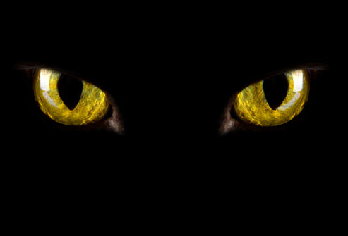
Glowing eyes
In this lab, you will use numpy arrays to make a cat’s eyes “glow” in an image. To do this we will create a Boolean filter which looks for greenish-blue parts of the image and makes them pierce the darkness.
- Load the provided “cat2.png” file as a numpy array using the matplotlib library.

- Create a new numpy array which is the ratio of green to blue channels in the image. You may get some divide by zero warnings, you can just add a very small amount onto each denominator element to fix these. Do not use a loop in this step.

- Create a new numpy array which is the ratio of green to red channels in the image (do not use a loop)

- Darken the image, EXCEPT in the following case: where the green-to-blue ratio is greater than 1.07 and the green-to-red ratio is greater than 1.07. Do not use a loop, use a Boolean filter for this. Careful with the logic here.

Hint: If it’s not working, often the problem is that you do not have enough parentheses.

- Display the image with matplotlib. If done correctly, the cat’s eye’s should appear to “glow” compared to the darker (but still visible) background (including the border, cat’s body, etc.).

